**Wracksweeper: ECE Subteam Milestones and Deliverables**

**Capstone Team 3, AUV**

**Sponsor:** Maritime Archaeological Society

**Adviser:** Dr. Martin Siderius

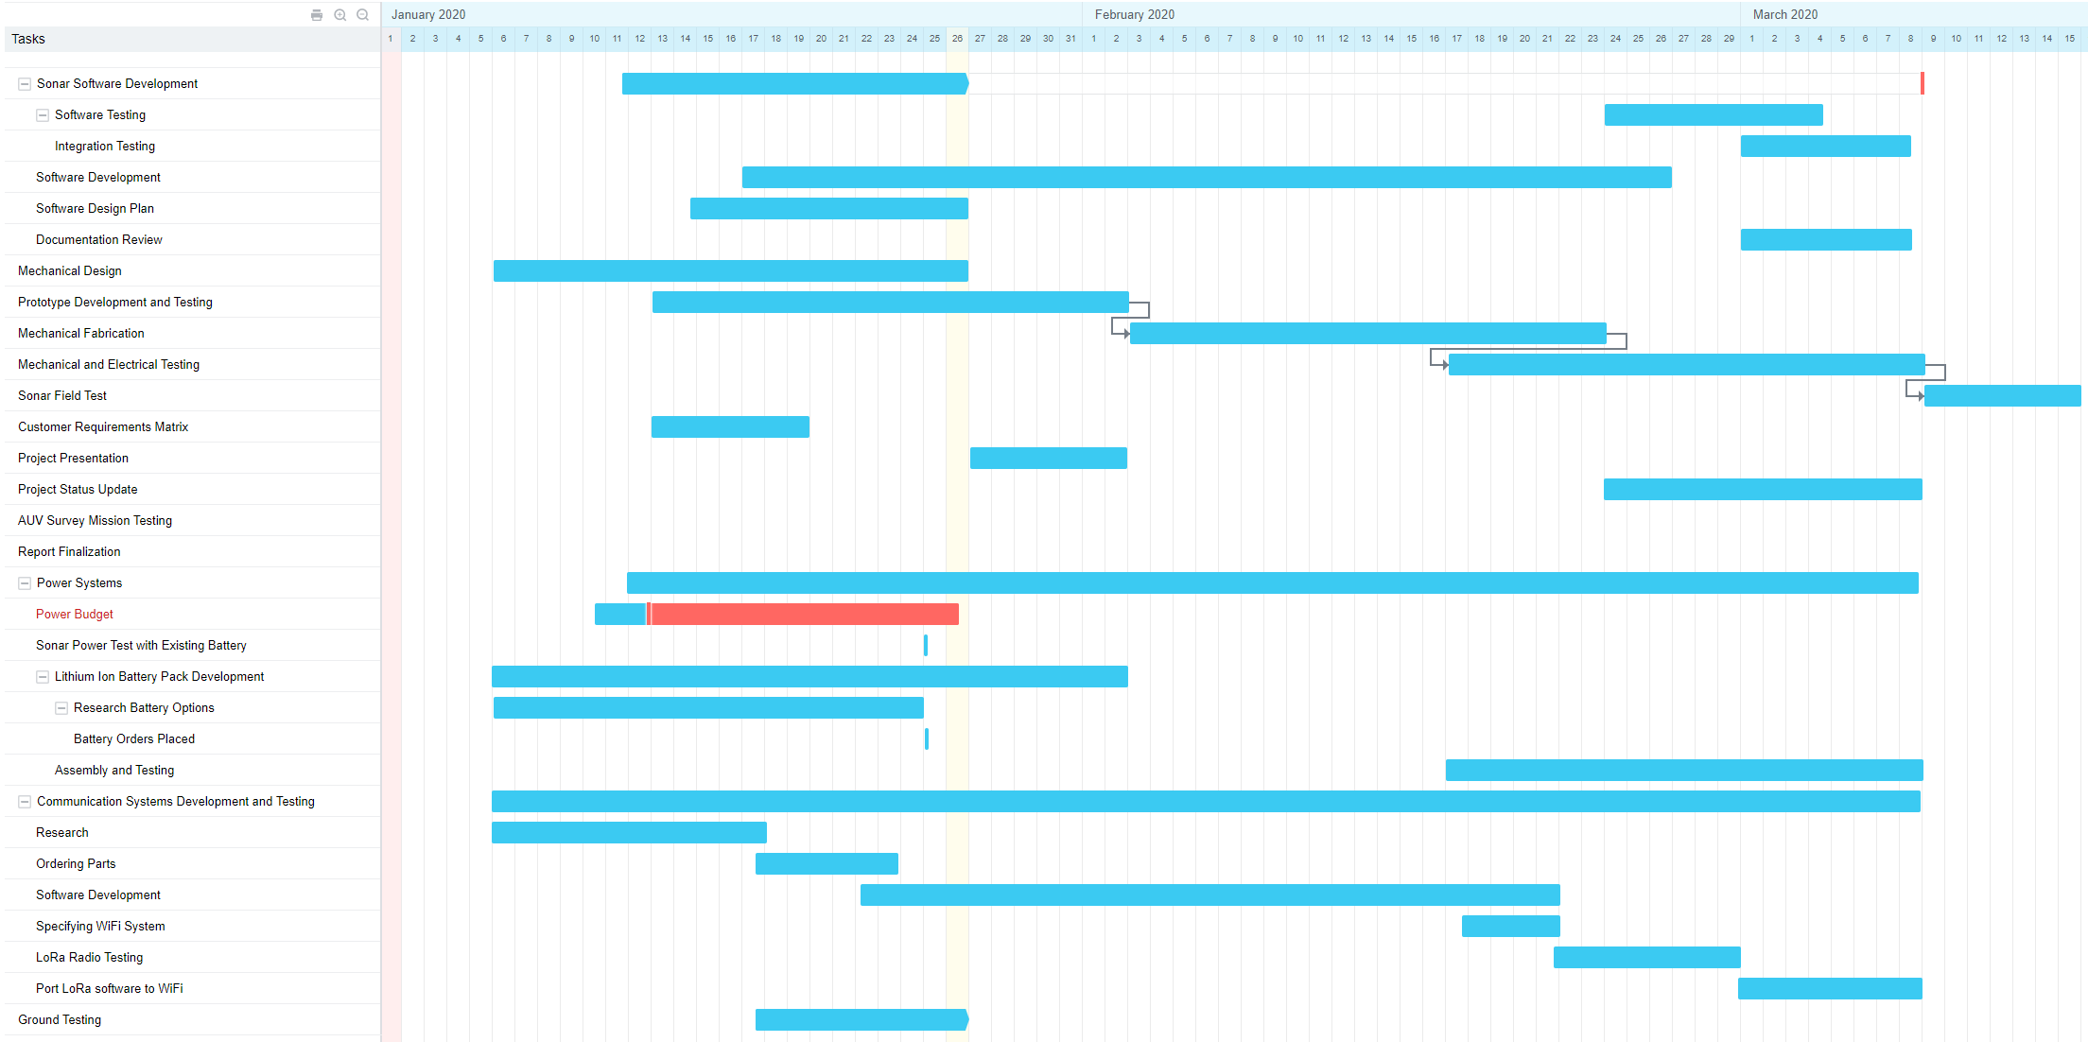

*Figure 1: Gantt chart for the Spring term portion of the project*

**Key Milestones**

1. Create product design specification.
2. Build project schedule.
3. Present project proposal to industry sponsor
4. Present final project to industry sponsor and faculty adviser
5. Specification milestones:
   1. Specify power module hardware
   2. Specify sonar integration software
   3. Specify emergency location services hardware
   4. Specify remote communications hardware
6. Modular Test Milestones
   1. Successfully test power system
   2. Successful hardware integration of power system
   3. Successfully test sonar hardware
   4. Successfully test sonar software
   5. Successful hardware integration of sonar
   6. Successfully test emergency location hardware
   7. Successful hardware integration of emergency location
   8. Successfully test remote communications hardware
   9. Successfully test remote communications software
   10. Successful hardware integration of remote communications
7. Integration Milestones
   1. Successful systems integration test (done on dry land)
      1. Create and store sonar images physically onto IC
      2. Get location from beacon
      3. Request and receive location from AUV using wireless communications, possibly update MOOS mission and/or retrieve sonar image data
      4. Recharge battery
8. Performance Test Milestones
9. Characterize battery life
   1. Characterize voltage regulation and boost voltage
10. Characterize sonar performance.
11. Characterize location accuracy of emergency locations hardware
12. Characterize remote communications datarate and range.
13. Successful test mission demonstrating full system operation in water
    1. Potentially: ocean-based demonstration mission to characterize ocean performance of system

**Key Deliverables**

1. Product Design Specification
2. Project Schedule
3. Software to run sidescan sonar on Linux-based computer
4. Software to allow remote user control of MOOS and possibly sonar using wireless communications.
5. AUV new features
   1. Side-scan sonar
   2. Rechargeable Battery System
   3. Asset tracking system
   4. Wireless communications system
6. Documentation
   1. Software documented sufficiently to allow new users to install, use, and possibly adapt any code
   2. “Piloting” guide to AUV to simplify the process of generating mission parameters for MOOS-IvP
   3. Written report describing full scope of project including data
   4. Datasheets for all added components.
   5. Full revision history of all code
   6. Recorded minutes from weekly meetings documenting project progress over time.
   7. System block diagram that details the full system and differentiates between legacy hardware and new additions done by the capstone team